Mini Project - 3

|  |  |
| --- | --- |
| **Student Name/ID Number:** | Agung Yuda Pratama / BDSE-0922-076 |
| **Unit Number and Title:** | ACWD Module 4 – Database Design & Implementation |
| **Academic Year:** | 2023 |
| **Unit Assessor:** |  |
| **Project Title:** | Develop Sample Data, Queries or Report, Test & Document Database |
| **Issue Date:** |  |
| **Submission Date:** |  |
| **Internal Verifier Name:** |  |
| **Date:** |  |

|  |
| --- |
| **Learner declaration** |
| I certify that the work submitted for this assignment is my own and research sources are fully acknowledged.  Student signature: Date: 18 January 2023 |

|  |
| --- |
| **Purpose of this project** |
| **Purpose of this project**  To demonstrate your capabilities in the following areas:   * Develop Sample Data for Reports * Develop Queries & Report * Test Database * Document Database |
| **Submission Format** |
| 1. Screen capture of Sample Data for Report 2. Queries for generating reports from database 3. Detailed description of Test Methods 4. Documentation of Database |
| **Project Brief & Guidance** |
| **Scenario:**  **Refer to the Project Scenario for the Module Project**  You have been approached by ‘ABC Jobs Pte Ltd’ as a website developer to develop a community portal for Software Developers. The project will be carried over through Module 3, Module 4, Module 5 and Capstone project. For this module the scope is to Design, Develop, Implement & Document Struts Framework Website.  The Scope of the Project is to design a Community Portal Similar to Linkedin.com. Users will be able to register in the portal using the Registration Page. Users of the portal can search for other users using various parameters such as First Name, Last Name, Company Name, City & Country. Users will be able to view the Public Profile of users after searching them. The portal allow users to login, request for forgotten password and Update their profile information  The scope of this mini project is to generate reports, test and document database.  **The overview of the project is as below**  There are 2 types of users in this Community portal. They are   1. Software Programmer 2. Administrator |

|  |
| --- |
| **Software Programmer should be able to perform following functions in the portal**   1. Allow the programmers to register in the portal, show a thank you page & send a registration confirmation email. 2. Search & Find Other Programmers after login and view their profile. 3. Provide Login Page 4. Provide password retrieval functionality. 5. Update their Profile after logging in.   Following Functionality is part of Database Design & Will be enhanced as features as required in the Capstone Project, Depending on time availability.   1. Send Messages to Each Other on the Portal 2. Create Threads & Post Replies to a Thread 3. Post Job Opportunities in the Portal   **Administrator should be able to perform following functions in the portal**   1. Administer user data. 2. Send bulk email inviting programmers to register on the community portal   **The portal consist of the following Key pages (For Reference)**   1. Community Portal Home Page 2. Registration Page 3. Registration Confirmation Page 4. Update Profile Page 5. Search Users Page 6. List Search Results 7. Public Profile Page 8. Registration Confirmation Email 9. Login Page 10. Forget Password Page 11. Design the Forget Password Confirmation Page   Following Functionality is part of Database Design and will not be part of development & Will be enhanced as features are required in the Capstone Project, Depending on time availability.   1. Send Messages 2. Read Messages 3. Post in Message Board 4. List Message Board 5. Read A Thread 6. Post Job Opportunities 7. List Job Opportunities & Responses   **The scope of this assignment**   1. Create test data for all tables suitable for generating reports 2. Design report and Create queries which will be used for generation of meaningful management reports. Present the report in HTML format (1 report) |

1. Discuss briefly test methods you will employ to test and validate the database and brief reasons why you choose each test.
2. Document the database
3. Create a batch script to backup database & schedule it to run every 6 hours using windows task scheduler. Provide the script, along with the screen capture of Windows Task scheduler.
4. Provide a Restoration script in case of failure

**The Solution**

1. **Test Data for Table**
2. **User Table**

INSERT INTO `community_portal`.`user` (`user_id`, `user_email`, `user_name`, `location`, `user_password`, `date_register`) VALUES ('1', 'user1@example.com', 'Richard Smith', 'Illinois', '12345', '03/12/2022');

INSERT INTO `community_portal`.`user` (`user_id`, `user_email`, `user_name`, `location`, `user_password`, `date_register`) VALUES ('2', 'user2@example.com', 'Agung Yuda', 'Yokohama', 'qwerty123', '21/10/2022');

INSERT INTO `community_portal`.`user` (`user_id`, `user_email`, `user_name`, `location`, `user_password`, `date_register`) VALUES ('3', 'user3@example.com', 'Abdul Rahman', 'Bandung', 'abc123', '01/02/2022');

INSERT INTO `community_portal`.`user` (`user_id`, `user_email`, `user_name`, `location`, `user_password`, `date_register`) VALUES ('4', 'user4@example.com', 'Michael Davis', 'New York', 'Mypass', '07/01/2023');

INSERT INTO `community_portal`.`user` (`user_id`, `user_email`, `user_name`, `location`, `user_password`, `date_register`) VALUES ('5', 'user5@example.com', 'Jalen Green', 'Ohio', 'Pass321', '05/01/2023');

INSERT INTO `community_portal`.`user` (`user_id`, `user_email`, `user_name`, `location`, `user_password`, `date_register`) VALUES ('6', 'user6@example.com', 'User1', 'New York', 'password123', ‘01/01/2022’);

INSERT INTO `community_portal`.`user` (`user_id`, `user_email`, `user_name`, `location`, `user_password`, `date_register`) VALUES ('7', 'user7@example.com', 'User2', 'Los Angeles', 'letmein', ‘01/12/2022’);

INSERT INTO `community_portal`.`user` (`user_id`, `user_email`, `user_name`, `location`, `user_password`, `date_register`) VALUES ('8', 'user8@example.com', 'User3', 'Houston', 'qwertop', ‘08/07/2022’);

INSERT INTO `community_portal`.`user` (`user_id`, `user_email`, `user_name`, `location`, `user_password`, `date_register`) VALUES ('9', 'user9@example.com', 'User4', 'Moscow', 'securepassword', ‘11/12/2022’);

INSERT INTO `community_portal`.`user` (`user_id`, `user_email`, `user_name`, `location`, `user_password`, `date_register`) VALUES ('10', 'user10@example.com', 'User5', 'London', 'hahihohe', ‘05/01/2023’);

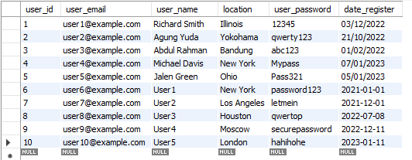

1. **Administrator Table**

INSERT INTO `community_portal`.`administrator` (`admin_id`, `admin_password`, `admin_email`, `admin_name`, `user_id`) VALUES ('1', 'Passadmin1', 'admin1@example.com', 'Jonatahn Berg', '1');

INSERT INTO `community_portal`.`administrator` (`admin_id`, `admin_password`, `admin_email`, `admin_name`, `user_id`) VALUES ('2', 'Passadmin2', 'admin2@example.com', 'Clara Fox', '2');

INSERT INTO `community_portal`.`administrator` (`admin_id`, `admin_password`, `admin_email`, `admin_name`, `user_id`) VALUES ('3', 'Passadmin3', 'admin3@example.com', 'Laura Love', '3');

INSERT INTO `community_portal`.`administrator` (`admin_id`, `admin_password`, `admin_email`, `admin_name`, `user_id`) VALUES ('4', 'Passadmin4', 'admin5@example.com', 'Michael Brown', '2');

INSERT INTO `community_portal`.`administrator` (`admin_id`, `admin_password`, `admin_email`, `admin_name`, `user_id`) VALUES ('5', 'Passadmin5', 'admin5@example.com', 'Crish John', '1');

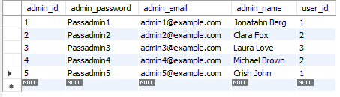

1. **Bulk Email Table**

INSERT INTO `community_portal`.`bulk_email` (`email_id`, `content`, `admin_id`) VALUES ('1', 'We are glad to declare the introduction of our new product ABC. You Can Join Us', '1');

INSERT INTO `community_portal`.`bulk_email` (`email_id`, `content`, `admin_id`) VALUES ('2', 'We encourage you to join us at a future event so you may discover more about our business.', '2');

INSERT INTO `community_portal`.`bulk_email` (`email_id`, `content`, `admin_id`) VALUES ('3', 'For the role of Full Stack Developer, we are presently hiring.', '3');

INSERT INTO `community_portal`.`bulk_email` (`email_id`, `content`, `admin_id`) VALUES ('4', 'Come join us on our community portal to share ideas, discuss, and learn together!', '4');

INSERT INTO `community_portal`.`bulk_email` (`email_id`, `content`, `admin_id`) VALUES ('5', 'Don\'t miss the opportunity to connect with experts in your field on our community portal!', '5');

INSERT INTO `community_portal`.`bulk_email` (`email_id`, `content`, `admin_id`) VALUES ('6', 'We are now recruiting for the position of Full Stack Developer.', '5');

INSERT INTO `community_portal`.`bulk_email` (`email_id`, `content`, `admin_id`) VALUES ('7', 'Come discuss, exchange ideas, and learn with us on our community site!', '4');

INSERT INTO `community_portal`.`bulk_email` (`email_id`, `content`, `admin_id`) VALUES ('8', 'We invite you to attend one of our upcoming events so you can learn more about our company.', '3');

INSERT INTO `community_portal`.`bulk_email` (`email_id`, `content`, `admin_id`) VALUES ('9', 'We are happy to announce the launch of our new product ABC. You Can Participate', '2');

INSERT INTO `community_portal`.`bulk_email` (`email_id`, `content`, `admin_id`) VALUES ('10', 'Don\'t miss out on the opportunity to interact with subject matter experts in your area through our community portal!', '1');

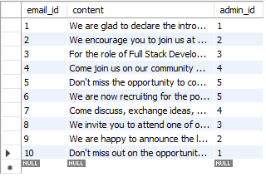

1. **Messages Table**

INSERT INTO `community_portal`.`messages` (`messages_id`, `date_send`, `content`, `receiver_id`, `sender_id`, `user_id`) VALUES ('1', '26/12/2022', 'Hi there, Agung Yuda! Thanks for being a valued member of the ABC community', '2', '1', '2');

INSERT INTO `community_portal`.`messages` (`messages_id`, `date_send`, `content`, `receiver_id`, `sender_id`, `user_id`) VALUES ('2', '18/08/2022', 'Hi Abdul Rahman, Whether your teams work in the same office or you work together from afar.', '3', '2', '3');

INSERT INTO `community_portal`.`messages` (`messages_id`, `date_send`, `content`, `receiver_id`, `sender_id`, `user_id`) VALUES ('3', '11/01/2023', 'Hello Jallen Green, how can I help you with our new product XYZ?', '5', '3', '5');

INSERT INTO `community_portal`.`messages` (`messages_id`, `date_send`, `content`, `receiver_id`, `sender_id`, `user_id`) VALUES ('4', '03/10/2022', 'content1', '1', '4', '1');

INSERT INTO `community_portal`.`messages` (`messages_id`, `date_send`, `content`, `receiver_id`, `sender_id`, `user_id`) VALUES ('5', '21/10/2022', 'content2', '4', '5', '4');

INSERT INTO `community_portal`.`messages` (`messages_id`, `date_send`, `content`, `receiver_id`, `sender_id`, `user_id`) VALUES ('6', '01/11/2022', 'content3', '6', '6', '6');

INSERT INTO `community_portal`.`messages` (`messages_id`, `date_send`, `content`, `receiver_id`, `sender_id`, `user_id`) VALUES ('7', '23/11/2022', 'content4', '7', '7', '7');

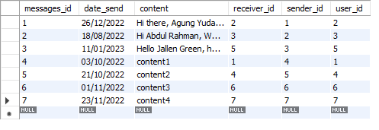

1. **Job Table**

INSERT INTO `community_portal`.`job` (`job_id`, `job_title`, `job_desc`, `company_id`, `company_name`) VALUES ('1', 'Software Engineer', 'Develop and maintain software applications for clients', '1', 'Acme Inc');

INSERT INTO `community_portal`.`job` (`job_id`, `job_title`, `job_desc`, `company_id`, `company_name`) VALUES ('2', 'Administrator', 'Manage and maintain a company\'s', '2', 'XYZ Corp');

INSERT INTO `community_portal`.`job` (`job_id`, `job_title`, `job_desc`, `company_id`, `company_name`) VALUES ('3', 'IT Project Manager', 'Plan, execute, and finalize projects according to strict deadlines and within budget', '3', 'ABC Technologies');

INSERT INTO `community_portal`.`job` (`job_id`, `job_title`, `job_desc`, `company_id`, `company_name`) VALUES ('4', 'Data Analyst', 'Collect, analyze, and interpret large data sets to identify patterns and trends', '4', '123 Consulting');

INSERT INTO `community_portal`.`job` (`job_id`, `job_title`, `job_desc`, `company_id`, `company_name`) VALUES ('5', 'Cybersecurity', 'Protect an organization\'s computer systems and networks from attack or unauthorized access', '5', 'Secure Systems Inc');

INSERT INTO `community_portal`.`job` (`job_id`, `job_title`, `job_desc`, `company_id`, `company_name`) VALUES ('6', 'DevOps Engineer', 'Responsible for the design and implementation of continuous integration, continuous delivery, and infrastructure as code.', '6', 'TechCo');

INSERT INTO `community_portal`.`job` (`job_id`, `job_title`, `job_desc`, `company_id`, `company_name`) VALUES ('7', 'Systems Administrator', 'Install, configure, and maintain operating systems, servers, and other IT infrastructure.', '7', 'DataWorks');

INSERT INTO `community_portal`.`job` (`job_id`, `job_title`, `job_desc`, `company_id`, `company_name`) VALUES ('8', 'Cloud Architect', 'Design and implement cloud-based solutions using technologies such as AWS, Azure, or Google Cloud. ', '8', 'DataWorks');

INSERT INTO `community_portal`.`job` (`job_id`, `job_title`, `job_desc`, `company_id`, `company_name`) VALUES ('9', 'Business Analyst', 'Gather and analyze business requirements to identify areas for improvement and implement solutions.', '9', 'BizTech Solutions');

INSERT INTO `community_portal`.`job` (`job_id`, `job_title`, `job_desc`, `company_id`, `company_name`) VALUES ('10', 'Artificial Intelligence Engineer', 'Design, develop, and implement artificial intelligence and machine learning models.', '10', 'AI Innovations');

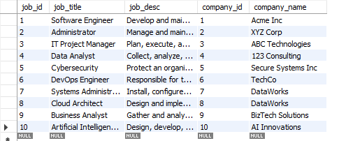

1. **Thread Table**

INSERT INTO `community_portal`.`thread` (`thread_id`, `user_id`, `tittle`, `content`, `date_created`) VALUES ('1', '5', 'Best programming languages for beginners', 'I am new to programming and am wondering what the best languages are to start with. Any suggestions?', '01/01/2023');

INSERT INTO `community_portal`.`thread` (`thread_id`, `user_id`, `tittle`, `content`, `date_created`) VALUES ('2', '1', 'Help with MySQL query optimization', 'I am having trouble optimizing a query in MySQL. Can anyone help?', '22/12/2022');

INSERT INTO `community_portal`.`thread` (`thread_id`, `user_id`, `tittle`, `content`, `date_created`) VALUES ('3', '4', 'JavaScript vs Python', 'I am trying to decide between JavaScript and Python for web development. What are the pros and cons of each?', '30/12/2022');

INSERT INTO `community_portal`.`thread` (`thread_id`, `user_id`, `tittle`, `content`, `date_created`) VALUES ('4', '1', 'How to fix a slow computer', 'My computer has been running slow recently and I\'m not sure how to fix it. Can anyone provide some tips or suggestions on how to speed it up?', '15/01/2023');

INSERT INTO `community_portal`.`thread` (`thread_id`, `user_id`, `tittle`, `content`, `date_created`) VALUES ('5', '2', 'Upgrading to Windows 10', 'I\'m planning on upgrading my work computer to Windows 10. Has anyone done this before and can provide some guidance?', '12/01/2023');

INSERT INTO `community_portal`.`thread` (`thread_id`, `user_id`, `tittle`, `content`, `date_created`) VALUES ('6', '10', 'title 1', 'Since I\'m new to programming, I\'m unsure of the best languages to learn first. Any recommendations?', '01/12/2022');

INSERT INTO `community_portal`.`thread` (`thread_id`, `user_id`, `tittle`, `content`, `date_created`) VALUES ('7', '9', 'title 2', 'For web programming, I\'m stuck between JavaScript and Python. What are each\'s benefits and drawbacks?', '10/12/2022');

INSERT INTO `community_portal`.`thread` (`thread_id`, `user_id`, `tittle`, `content`, `date_created`) VALUES ('8', '8', 'title 3', 'For web programming, I\'m stuck between JavaScript and Python. What are each\'s benefits and drawbacks?', '20/12/2022');

INSERT INTO `community_portal`.`thread` (`thread_id`, `user_id`, `tittle`, `content`, `date_created`) VALUES ('9', '7', 'title 4', 'My computer has been running slow recently and I\'m not sure how to fix it. Can anyone provide some tips or suggestions on how to speed it up?', '30/12/2022');

INSERT INTO `community_portal`.`thread` (`thread_id`, `user_id`, `tittle`, `content`, `date_created`) VALUES ('10', '6', 'title 5', 'My work computer will soon be upgraded to Windows 10. Can anyone who has done this before offer some advice?', '07/01/2023');

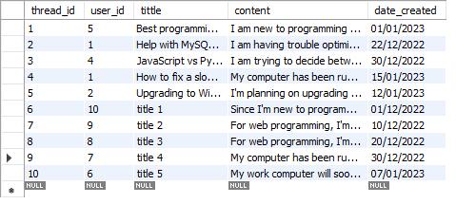

1. **Apply Table**

INSERT INTO `community_portal`.`apply` (`user_id`, `job_id`) VALUES ('3', '5');

INSERT INTO `community_portal`.`apply` (`user_id`, `job_id`) VALUES ('2', '1');

INSERT INTO `community_portal`.`apply` (`user_id`, `job_id`) VALUES ('1', '3');

INSERT INTO `community_portal`.`apply` (`user_id`, `job_id`) VALUES ('5', '4');

INSERT INTO `community_portal`.`apply` (`user_id`, `job_id`) VALUES ('4', '2');

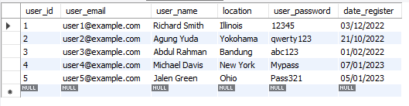

1. **Make Table**

INSERT INTO `community_portal`.`make` (`user_id`, `thread_id`) VALUES ('5', '1');

INSERT INTO `community_portal`.`make` (`user_id`, `thread_id`) VALUES ('1', '2');

INSERT INTO `community_portal`.`make` (`user_id`, `thread_id`) VALUES ('4', '3');

INSERT INTO `community_portal`.`make` (`user_id`, `thread_id`) VALUES ('1', '4');

INSERT INTO `community_portal`.`make` (`user_id`, `thread_id`) VALUES ('5', '2');

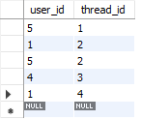

1. **User_education Table**

INSERT INTO `community_portal`.`user_education` (`education`, `user_id`) VALUES ('Bachelor\'s', '1');

INSERT INTO `community_portal`.`user_education` (`education`, `user_id`) VALUES ('Master’s, ', '1');

INSERT INTO `community_portal`.`user_education` (`education`, `user_id`) VALUES ('Master’s, ', '2');

INSERT INTO `community_portal`.`user_education` (`education`, `user_id`) VALUES ('Ph.D', '3');

INSERT INTO `community_portal`.`user_education` (`education`, `user_id`) VALUES ('High School', '4');

INSERT INTO `community_portal`.`user_education` (`education`, `user_id`) VALUES ('Bachelor\'s', '5');

INSERT INTO `community_portal`.`user_education` (`education`, `user_id`) VALUES ('Master’s, ', '5');

INSERT INTO `community_portal`.`user_education` (`education`, `user_id`) VALUES ('High School', '6');

INSERT INTO `community_portal`.`user_education` (`education`, `user_id`) VALUES ('High School', '7');

INSERT INTO `community_portal`.`user_education` (`education`, `user_id`) VALUES ('Bachelor\'s', '8');

INSERT INTO `community_portal`.`user_education` (`education`, `user_id`) VALUES ('Master’s, ', '9');

INSERT INTO `community_portal`.`user_education` (`education`, `user_id`) VALUES ('Master’s, ', '10');

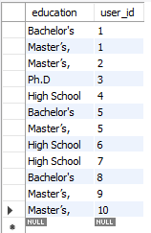

1. **Job_location Table**

INSERT INTO `community_portal`.`job_location` (`location`, `job_id`) VALUES ('Tokyo', '1');

INSERT INTO `community_portal`.`job_location` (`location`, `job_id`) VALUES ('Singapore', '1');

INSERT INTO `community_portal`.`job_location` (`location`, `job_id`) VALUES ('Chicago', '2');

INSERT INTO `community_portal`.`job_location` (`location`, `job_id`) VALUES ('Dubai', '3');

INSERT INTO `community_portal`.`job_location` (`location`, `job_id`) VALUES ('Qatar', '3');

INSERT INTO `community_portal`.`job_location` (`location`, `job_id`) VALUES ('Indonesia', '4');

INSERT INTO `community_portal`.`job_location` (`location`, `job_id`) VALUES ('Brazil', '5');

INSERT INTO `community_portal`.`job_location` (`location`, `job_id`) VALUES ('Canada', '6');

INSERT INTO `community_portal`.`job_location` (`location`, `job_id`) VALUES ('China', '7');

INSERT INTO `community_portal`.`job_location` (`location`, `job_id`) VALUES ('Russia', '8');

INSERT INTO `community_portal`.`job_location` (`location`, `job_id`) VALUES ('Italy', '9');

INSERT INTO `community_portal`.`job_location` (`location`, `job_id`) VALUES ('Turkey', '10');

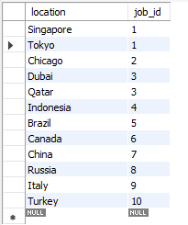

1. **Queries Table**

|  |  |  |  |
| --- | --- | --- | --- |
| No | Note | Query | Evidence |
| 1 | All users contact info.  To fetch users, contact info information | SELECT user_id, user_name AS Name, CONCAT(location,", ",date_register) AS User_Data, concat(user_email, " / ", user_password) AS Login_Credential  FROM user  ORDER BY Name; | Report users contact log |
| 2 | All jobs description info, To fetch job type information | SELECT j.job_id, concat(j.company_id, " / ",j.company_name, " / ", jl.location) AS Company, concat(j.job_title," / ",j.job_desc) AS Description  FROM job as j JOIN job_location as jl ON j.job_id = jl.job_id  ORDER BY Job_Desc; | Report jobs description log |
| 3 | All user that registered in 2022 | SELECT date_register, concat(user_id,' / ',user_name) AS User_data, location AS City  From user where date_register between '01/01/2022' and '31/12/2022'  ORDER BY date_register; | Report of User that registered in 2022 |

**Report users contact log**

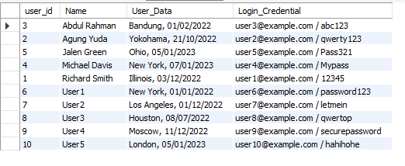

**Report jobs description log**

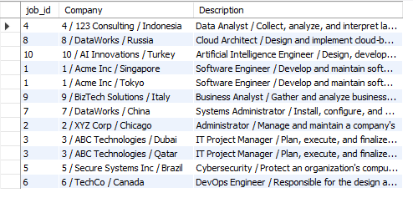

**Report of User that registered in 2022**

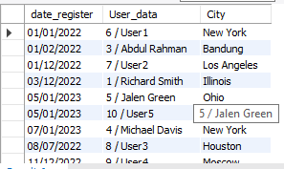

1. **Discuss briefly test methods you will employ to test and validate the database and brief reasons why you choose each test.**
2. **Structural Database Testing**
3. Schema Testing

Schema or database testing is vital in ensuring the validity of data received and stored in the database.

|  |  |  |  |  |
| --- | --- | --- | --- | --- |
| No. / Test Cases | Expected Result | Actual Result | Test Result | Evidence |
| 1. Schema Testing: Ensure that the Relationship Schema and EER Diagram are the same in terms of (table name, attributes, primary key, and foreign key) | Both Relationship schema and EER Diagram should be the same | Both the Relationship schema and EER diagram are same | Pass | Screen capture of logical design and physical design (EERD) |

Evidence

**Relationship Schema**

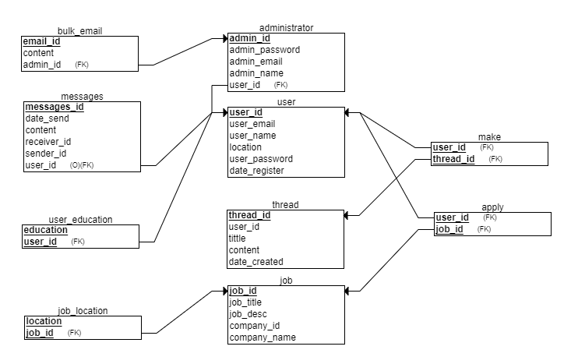

**EER Diagram**

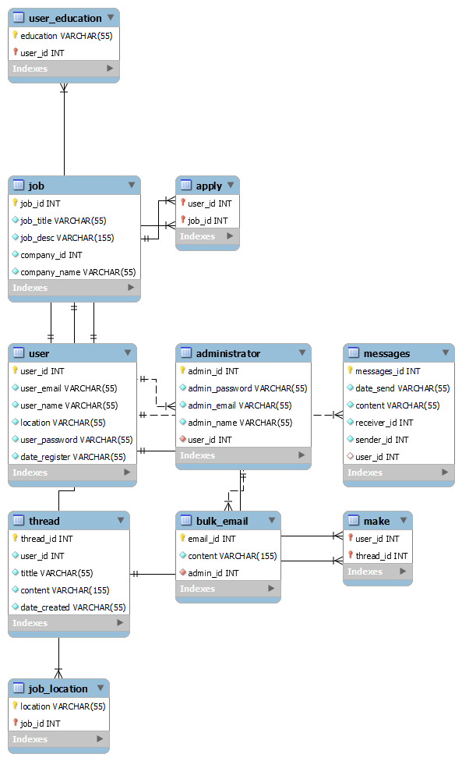

1. **Table/Column Testing**

Every transaction or sequence of operations performed using SQL statement must conform to the ACID properties validation.

|  |  |  |  |  |  |
| --- | --- | --- | --- | --- | --- |
| TestCase ID | Test case | Expected result | Actual result | Pass / Fail | Evidence |
| TC01 | 1. Primary Key testing: Insert duplicate value for primary key column for ‘user’ table | Error message should appear because duplicate value will be inserted into primary key column violating the rule | Error message appear because duplicate value is inserted into primary key column | Pass | Evidence screen capture No TC01 |
| TC02 | 2. Primary Key testing: Insert duplicate value for primary key column for ‘administrator’ table | Error message should appear because duplicate value will be inserted into primary key column violating the rule | Error message appear because duplicate value is inserted into primary key column | Pass | Evidence screen capture No TC02 |
| TC03 | 3. checking data size of bulk_email table | Error message should appear because data size is less | Error message should appear because data size is too long | Pass | Evidence screen capture No TC03 |
| TC04 | 4. Primary Key testing: Insert duplicate value for primary key column for ‘messages’ table | Error message should appear because duplicate value will be inserted into primary key column violating the rule | Error message appear because duplicate value is inserted into primary key column | Pass | Evidence screen capture No TC04 |
| TC05 | 5. Primary Key testing: Insert duplicate value for primary key column for ‘job’ table | Error message should appear because duplicate value will be inserted into primary key column violating the rule | Error message appear because duplicate value is inserted into primary key column | Pass | Evidence screen capture No TC05 |
| TC06 | 6. checking data size of thread table | Error message should appear because data size is less | Error message should appear because data size is too long | Pass | Evidence screen capture No TC06 |

**Evidence**

|  |  |
| --- | --- |
| **TC01** |  |
| **TC02** |  |
| **TC03** |  |
| **TC04** |  |
| **TC05** |  |
| **TC06** |  |

1. **Functional Database Testing**

Functional database testing is to test whether data in the database can be accessed and updated by the users and applications, all CRUD.

|  |  |  |  |  |  |
| --- | --- | --- | --- | --- | --- |
| TestCase ID | Test Case | Expected Result | Actual Result | Test Result | Evidence |
| FC001 | 1. Insert record into ‘user’ table | A record should successfully insert into 'user' table. | Record is successfully inserted into ‘user’ table | Pass | FC001 Fig |
| FC002 | 2. update record ‘user’ table | A record should successfully update 'user' table. | Record is successfully updated ‘user’ table | Pass | FC002 Fig |
| FC003 | 3. delete record ‘user’ table | A record should successfully delete 'user' table. | Record is successfully deleted ‘user’ table | Pass | FC003 Fig |
| FC004 | 4. select record into ‘user’ table | A record should successfully select into ‘user’ table. | Record is successfully selected into ‘user’ table | Pass | FC004 Fig |

**Evidence**

|  |  |
| --- | --- |
| **FC001** |  |
| **FC002** |  |
| **FC003** |  |
| **FC004** |  |

1. **Non-Functional Database Testing**

Non –functional specify the quality of a database’s characteristics or attributes based on performance, capacity, data integrity, security, and more. This requirement describes more on how the product works through testing like load, stress, security and others.

**Load Testing**

|  |  |  |  |
| --- | --- | --- | --- |
| No | Test case | Note | Evidence |
| 1 | Auto generate | Test performance of the device for simple test using auto generate from the mysqlslap with 50 users and 10 repetitions. | Load test 1 |
| 2 | custom query from the auto generates | Test performance with custom query using schema from auto generate with 50 users and 10 repetitions. | Load test 2 |

**Load Testing 1**

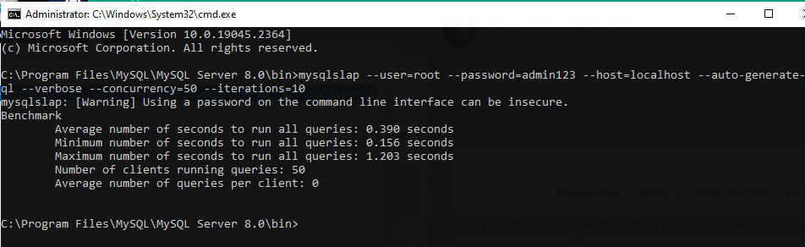

**Load Testing 2**

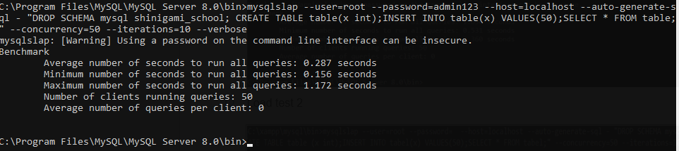

1. **Document Database**
2. **Start XAMPP Control Panel and open phpMyAdmin and Generate SQL**

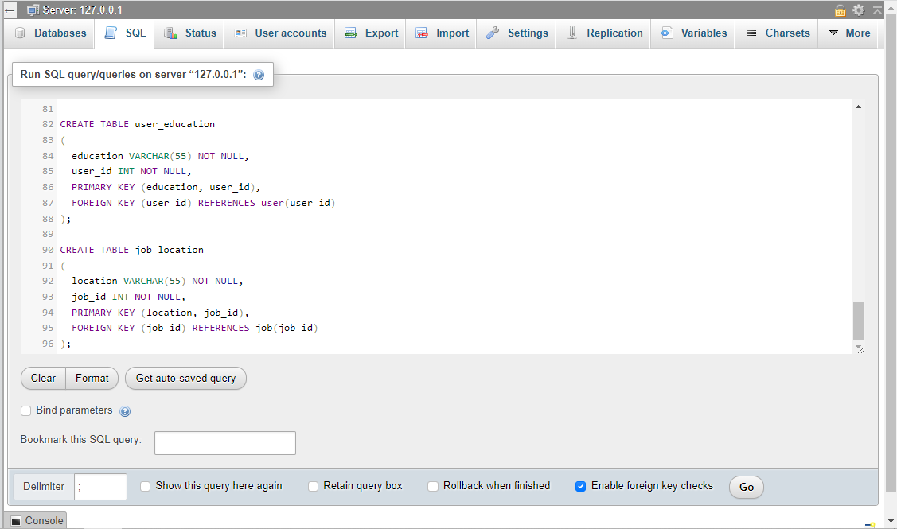

1. **After the Table generate, Check All Table**

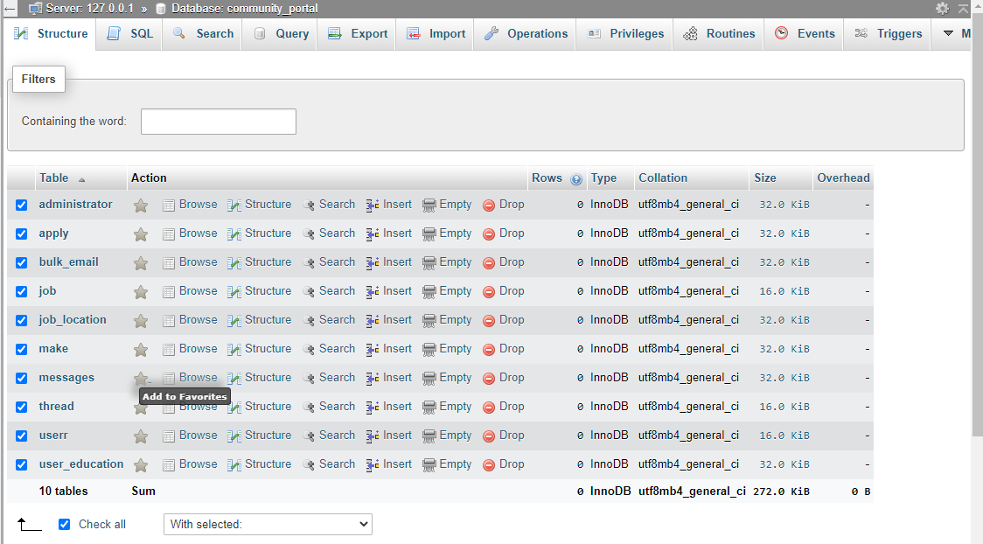

1. **Now see and print the data dictionary generated and we provide**

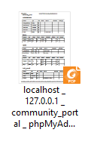

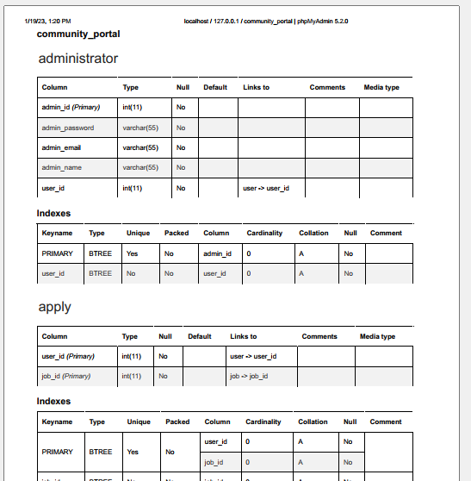

1. **Batch script to backup database & schedule it to run every 6 hours**

Create a batch file with backup script

* Open a text file, such as a Notepad or Notepad ++.
* Paste below code in file.
* Save file with .bat extension for example, **autobackup.bat.**

**For single database backup**

1. Create basic Task

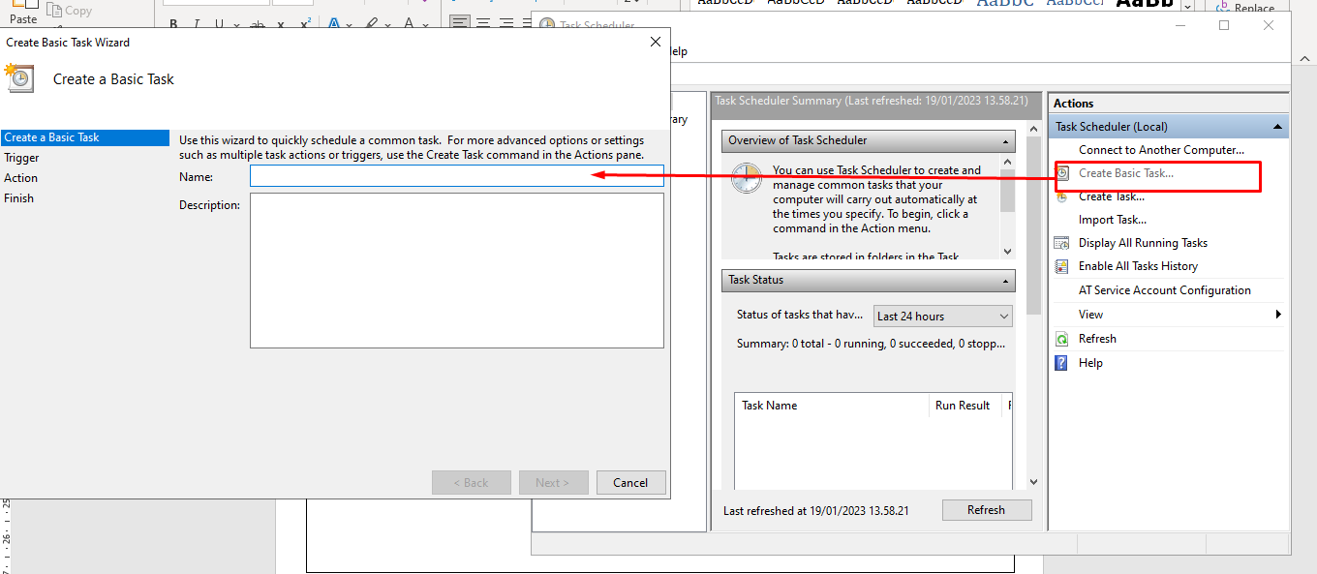

1. Fulfill the form name of the task and description

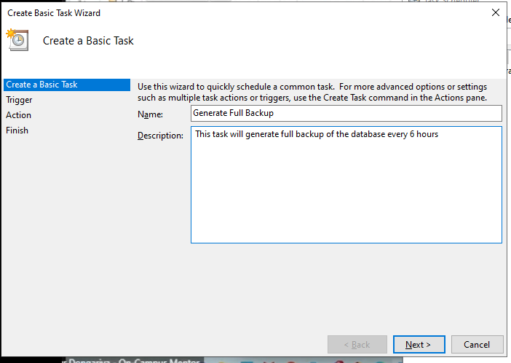

1. Choose Daily

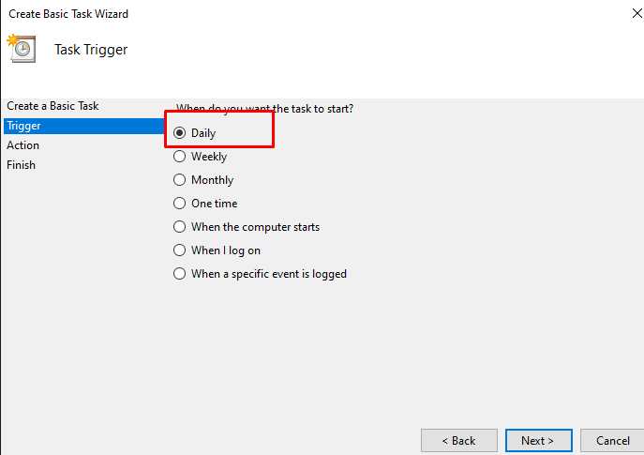

1. Specify in 6:00:00 in time box and 6 in day box

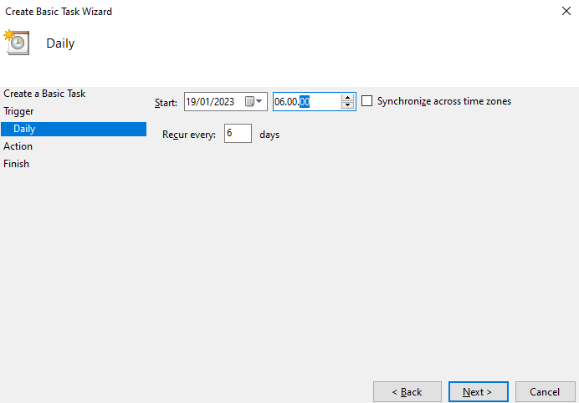

1. Start Program

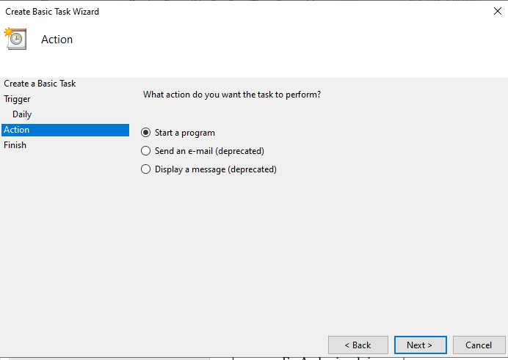

1. And browse the script that we had made before

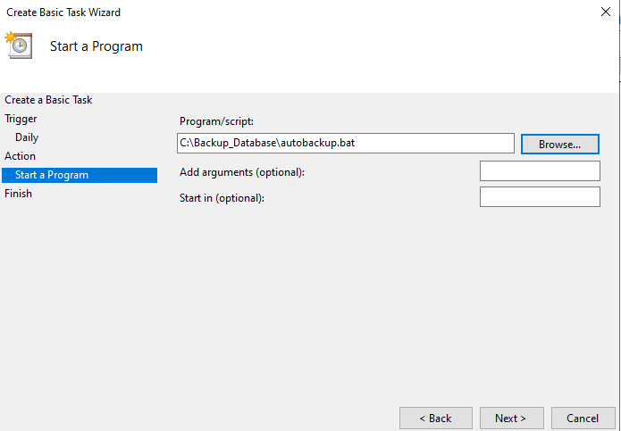

1. Click finish

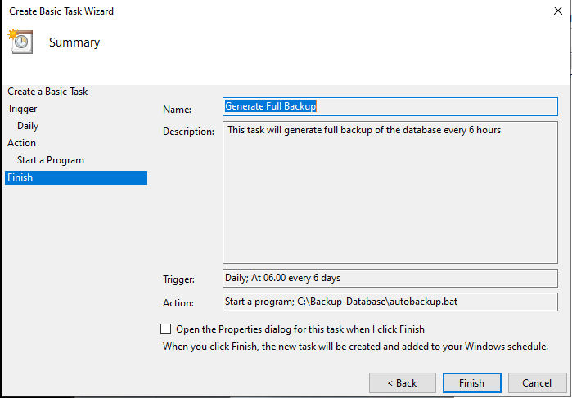

1. You can see the program right here

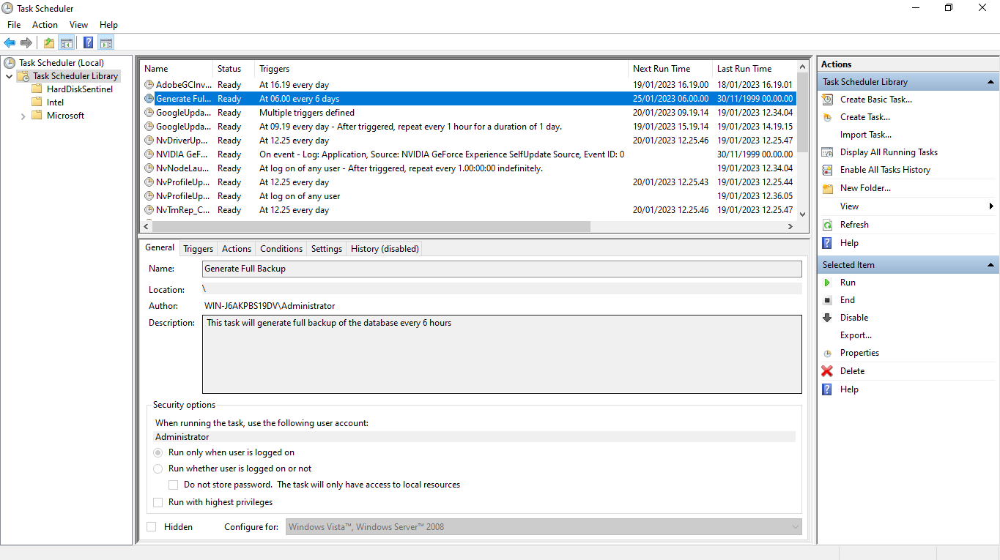

1. Now we can run this program with right click on task

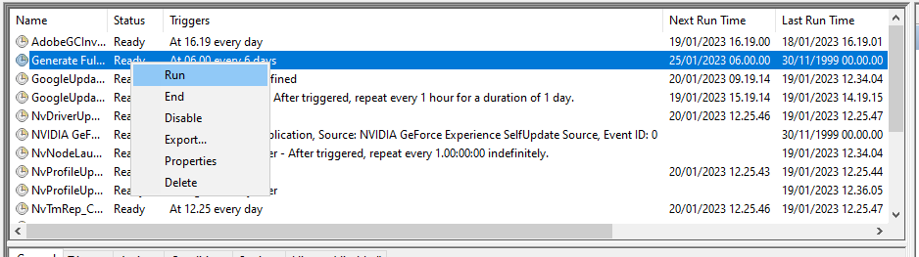

1. Now the program is running

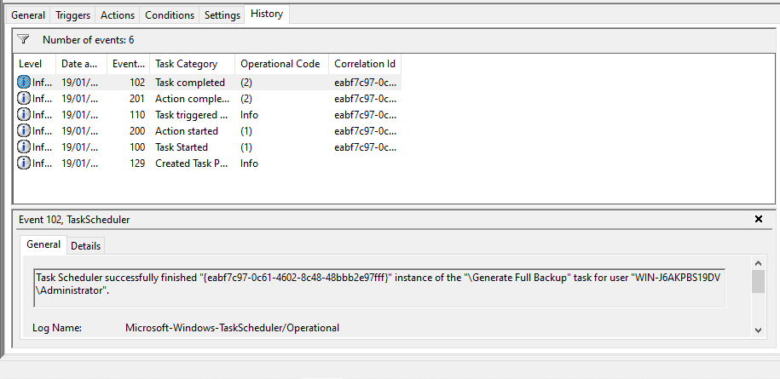

1. **Provide a Restoration script in case**

**This is how to import and export data on MySQL Workbench**

|  |  |
| --- | --- |
| Run Workbench, login to your account, in the left side choose administration and select data export.  Choose schema you want to export |  |
| Run Workbench, login to your account, in the left side choose administration and select data import.  Choose file path the project dump folder |  |

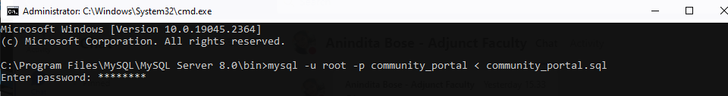THIS IS THE RESTORATION SCRIPT CASE